Data Communication and Network
LAB

FAROOQ AHMAD Experiment # 1
17L4407 Lab Report # 1
BEE-5A

Introduction to Networking Concepts

INTRODUCTION
It was the very first introductory lab session of the data communication and networks of fall 2020 conducted by future Dr. Mr. Zeeshan Asif. This lab session was beautifully conducted online on Google meet successfully. In this lab session, he beautifully explained the content elements of DCN lab manual experiment no. 1. We were introduced to the basic terminologies of the data communication and networks. These terms includes
- Nodes
- Topology
- Interface card
- Ethernet
- CAT 5 and CAT 6
- RJ45 connector
- cross cable
- straight cable

OBJECTIVE

The course learning objective of this lab session was to get familiarized with network cables and network interface card and to learn different topologies.

DESIGN PROCEDURE

Technical terminologies in data networks and their description
Node:
Any electronic device that is attached to a network and is capable of sending, receiving, or forwarding information over a communications channel.
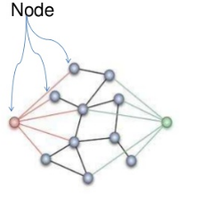
Topology:
The manner in which the nodes and links are physically arranged in a network.
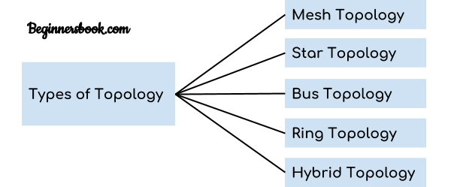
Interface Card:
The interface card for each computer is similar in structure although its shape may be different. Just like all humans are same in structure but different in appearance.
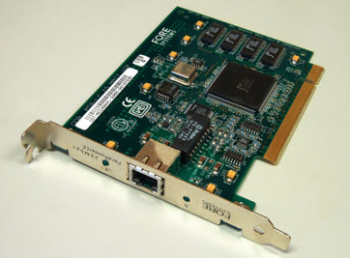
Ethernet cable structure:
An Ethernet cable consists of four pairs of wires. In order to identify the wires at the ends the pairs are colored.
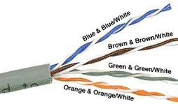
CAT5 and CAT6 cable:
Category 5 cable includes four twisted pairs in a single cable jacket. This use of balanced lines helps preserve a high signal-to-noise ratio despite interference from both external sources and other pairs.
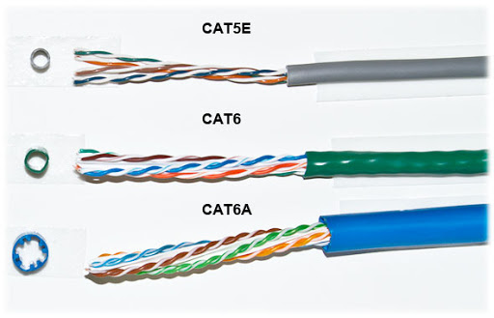
RJ45 connector (8P8C):
8 points 8 contact
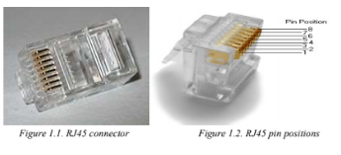
Cross cable/Straight cable
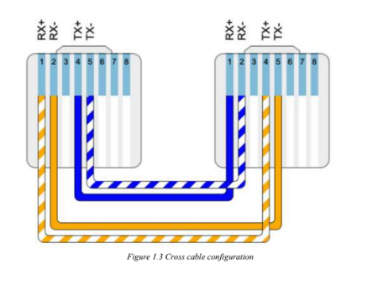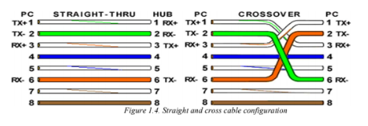

The OSI model:
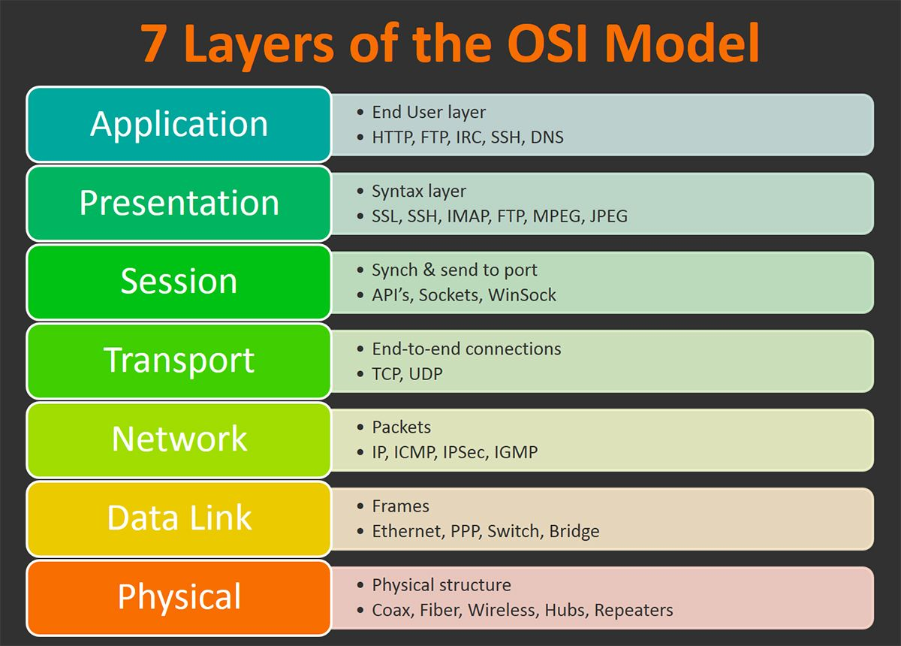

ISSUES
Usman Aziz sb section nahi change kr rahy bas.

CONCLUSION

The introductory lab session of the introduction to the frequently used data communication and network technical terminologies was conducted successfully. We were introduced and familiarized to the dcn content elements mentioned above. Moreover had a thorough go through of the OSI model and the 7 layered structure.

APPLICATIONS

Applications of Communication & Computer Network
- Resource sharing such as printers and storage devices.
- Exchange of information by means of e-Mails and FTP.
- Information sharing by using Web or Internet.
- Interaction with other users using dynamic web pages.
- IP phones.
- Video conferences.
- Parallel computing.
- Instant messaging.

POST LAB
There are five types of topology in computer networks:
1. Mesh Topology
2. Star Topology
3. Bus Topology
4. Ring Topology
5. Hybrid Topology

MESH Topology
It is a point-to-point connection to other nodes or devices. All the network nodes are connected to each other. Mesh has n(n-1)/2 physical channels to link n devices.
There are two techniques to transmit data over the Mesh topology, they are:
- Routing
- Flooding

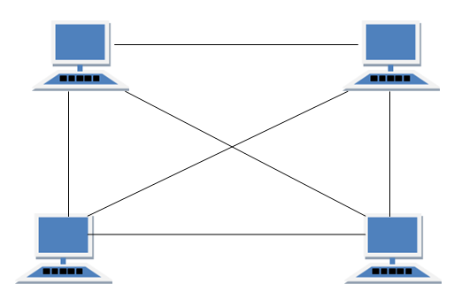

STAR Topology
In this type of topology all the computers are connected to a single hub through a cable. This hub is the central node and all others nodes are connected to the central node.
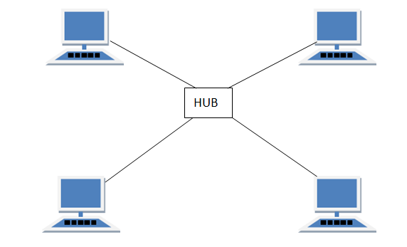

BUS Topology
Bus topology is a network type in which every computer and network device is connected to single cable. When it has exactly two endpoints, then it is called Linear Bus topology.
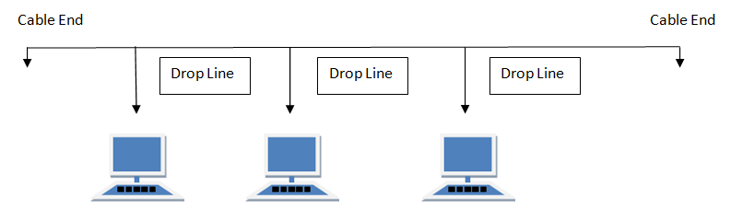

RING Topology
It is called ring topology because it forms a ring as each computer is connected to another computer, with the last one connected to the first. Exactly two neighbors for each device.
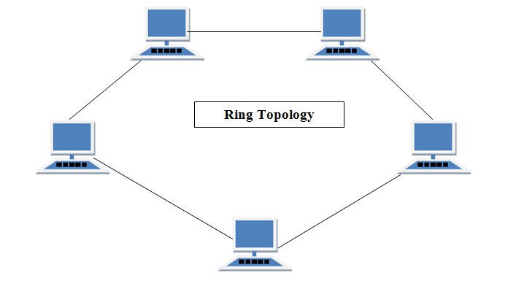

HYBRID Topology
It is two different types of topologies which is a mixture of two or more topologies. For example if in an office in one department ring topology is used and in another star topology is used, connecting these topologies will result in Hybrid Topology (ring topology and star topology).
